**NAME :**Leela Sekhar Chowdary Mannava

**ID(700#) :**700740979

**E-Mail :**lxm09790@ucmo.edu

**Assignment :**1

**Tools :**Google Colab

**Programming:** Python

**GitHub**

**Link:** [**https://github.com/LXM09790/ML-Assignment1.git**](https://github.com/LXM09790/ML-Assignment1.git)

**Question1**

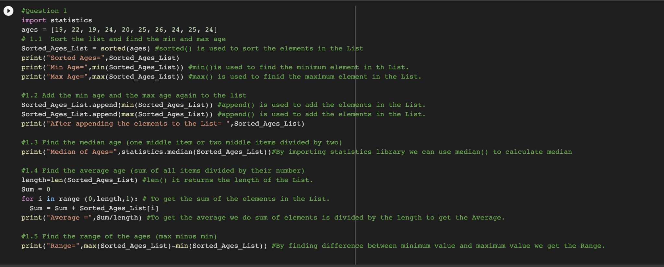

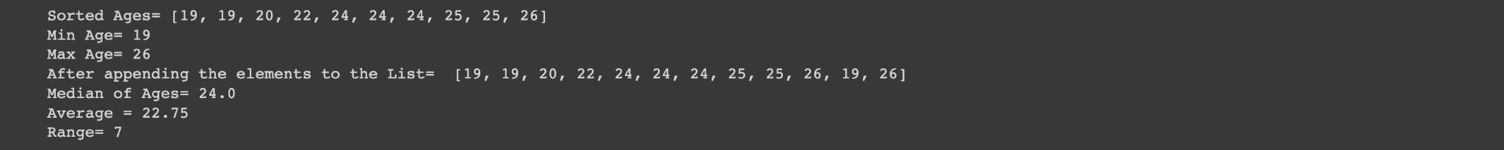

**Explanation:**

Given ages = [19, 22, 19, 24, 20, 25, 26, 24, 25, 24]

* Using the sorted() method the ages are sorted and printed on the sorted ages List.
* Using min() and max() i had discovered the minimum age and maximum in the given ages List.
* Using append() i again append the values of minimum age and maximum age to the list.
* We have a library called Statistics. By importing we can access median(). We can find the median of the ages List.
* By calculating the sum of elements in the list and length of the list. By applying sum/length we can get the average.
* Range can be calculated by differentiating minimum value and maximum value.

**Question2:**

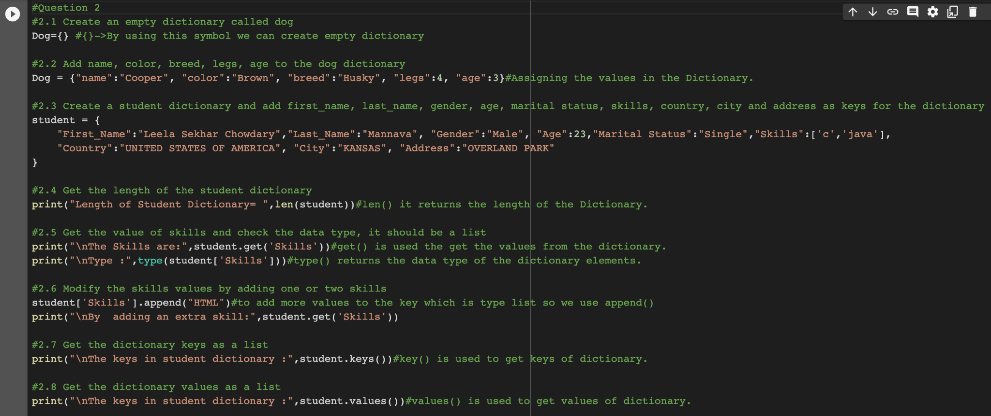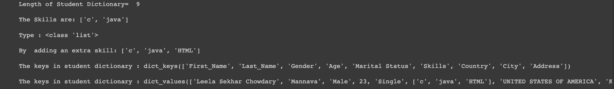

**Explanation:**

* Created an empty dictionary called dog{}
* Adding the attributes to the dictionary.
* Created a student dictionary by adding the key and values.
* By using len() I calculated the dictionary length of the student.
* By using type() we can find the type of values.
* Using append() I added new skills to the dictionary. get()is used to get the values of the dictionary based on key.
* By using keys() we can access the keys in the dictionary.
* By using Values() we can access the values in the dictionary.

**Question3:**

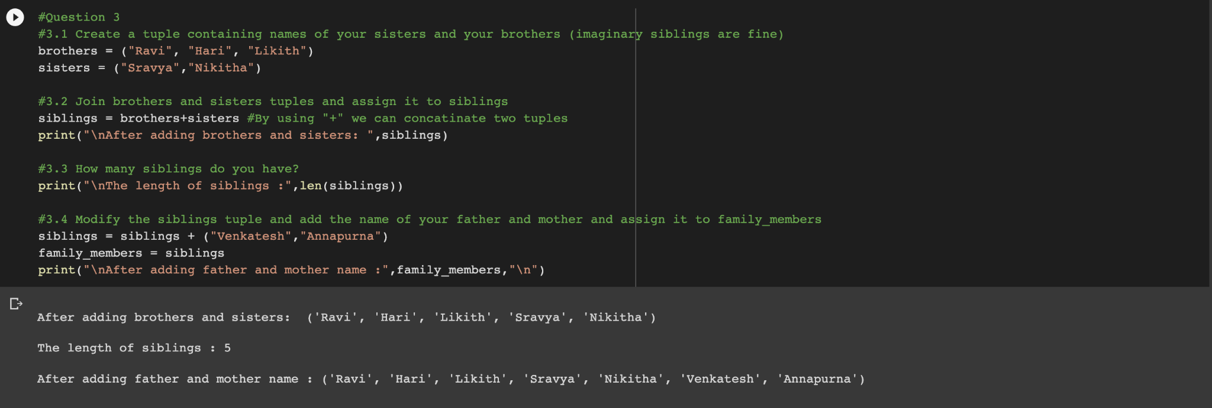

**Explanation:**

* Created a Brother and Sister tuples().
* Using the symbol “+” , we can concatenate the two tuples.
* By using len() we can calculate the length of the Tuple.
* By adding the new elements to the tuple like family members and concatenate to the family member tuple.

**Question4:**

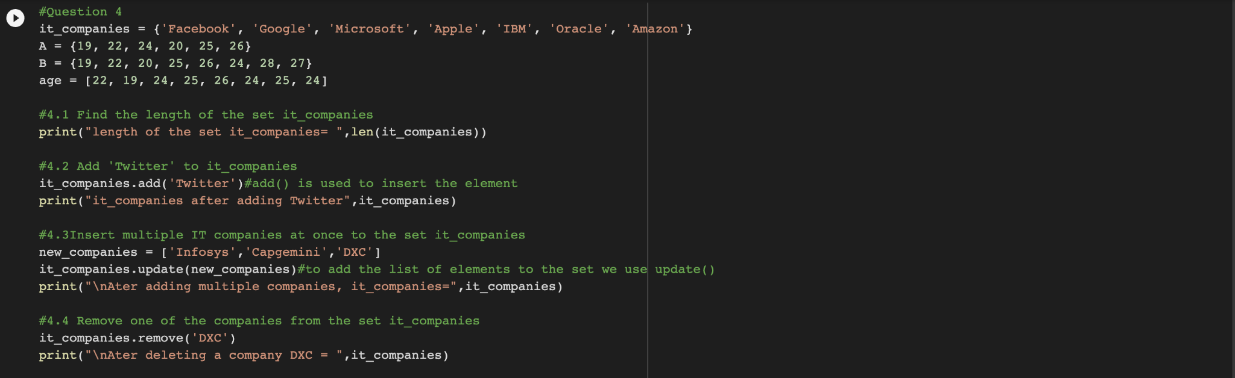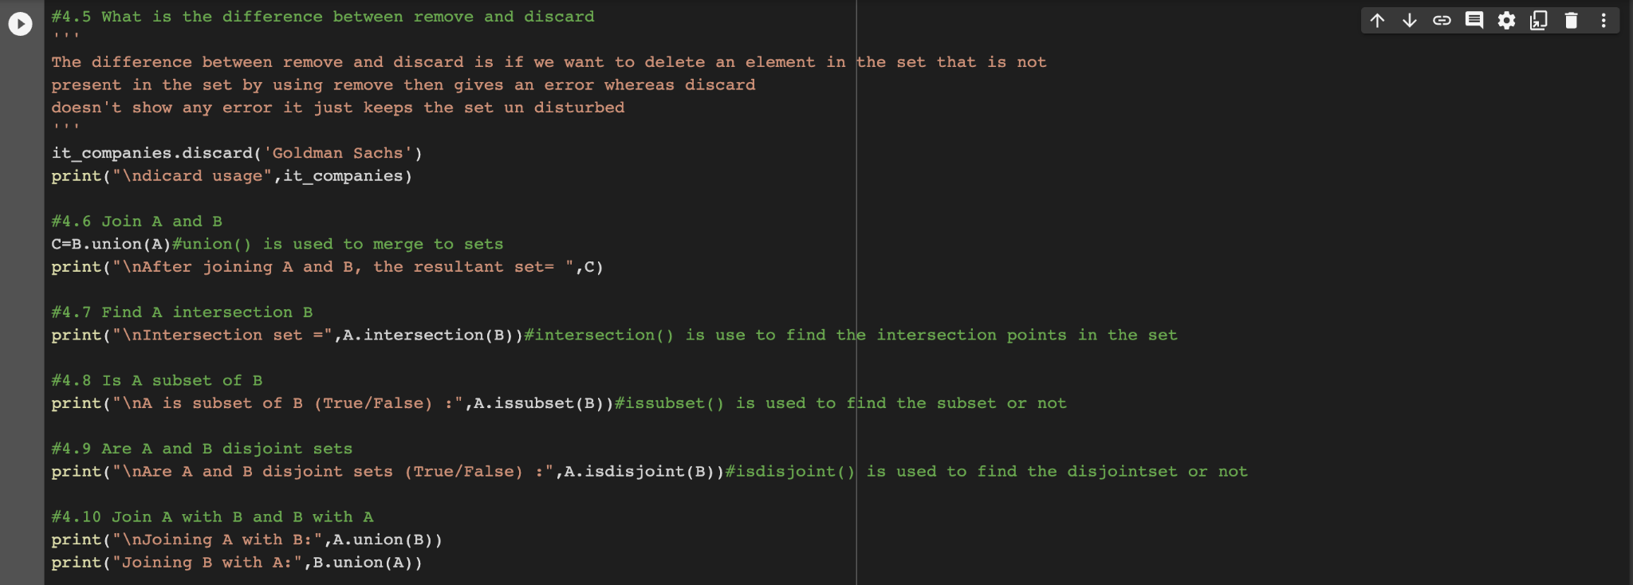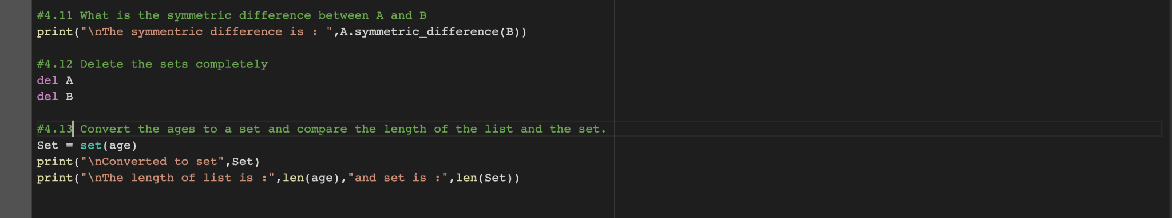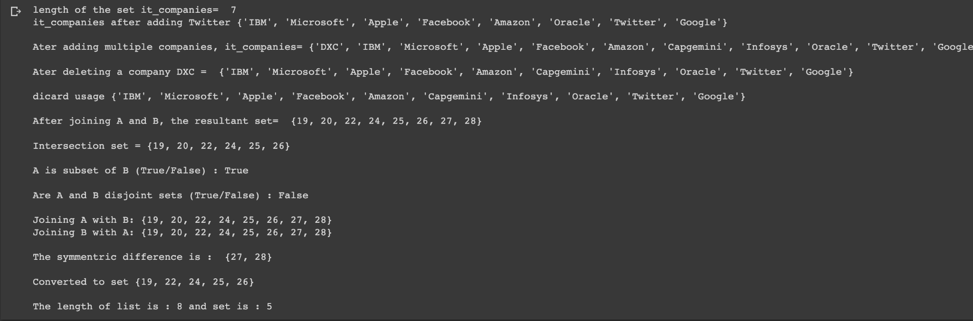

**Explanation:**

* Using len(),we can find out the length of the Set.
* add() is used to add the new element into the Set.
* remove() is used to remove an element from the Set.
* A.union(B)is an inbuilt function to join the two Sets.
* To find out the intersection, subset, disjoint, symmetric difference we have in built functions like intersection(),issubset(),isdisjoint(),Symmetric_difference().
* To convert a list to set we use set().

**Question5:**

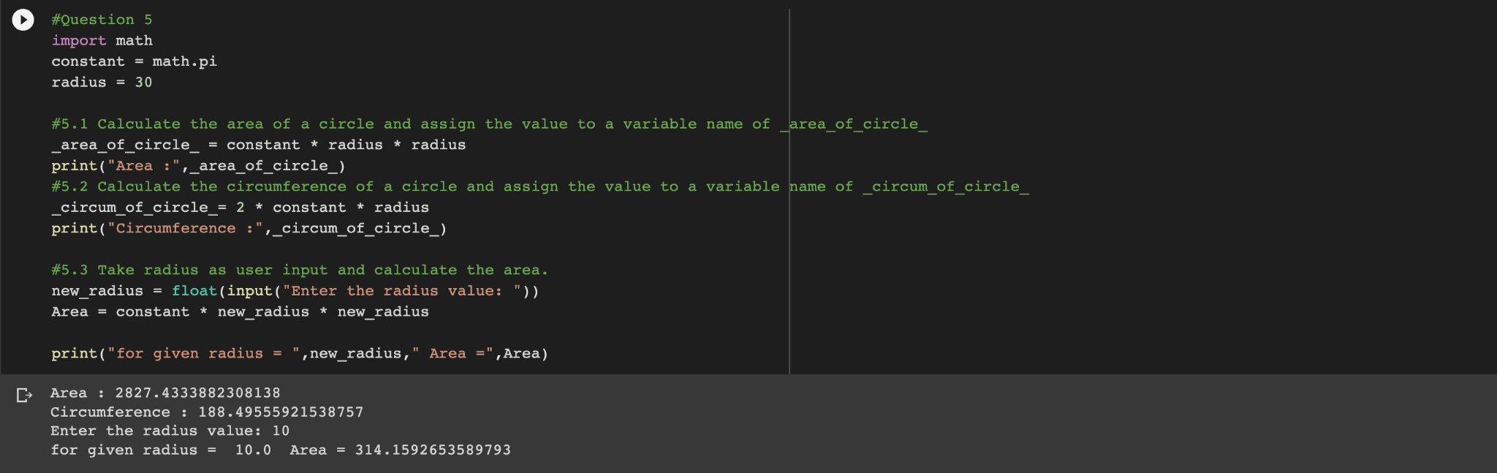

**Explanation:**

* We have radius 30 and we can calculate area of circle based on formula 3.14*radius**2.
* Circumference can be calculated based on 2*3.14*radius.
* We can use input() to get the input dynamically.

**Question6:**

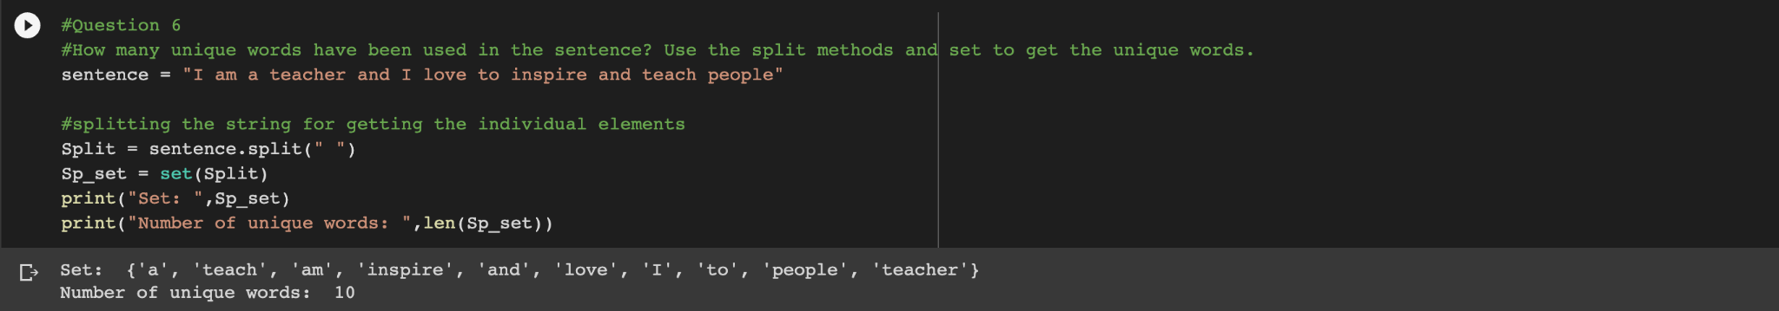

**Explanation:**

* We can use split() to split the elements.
* By using the Set we can store the unique values in the given string.Based on the length of the set we can get the count of unique elements.

**Question7:**



**Explanation:**

* \n is used to print the values in a new line.
* \t is used to print them by applying tab spaces.

**Question8:**

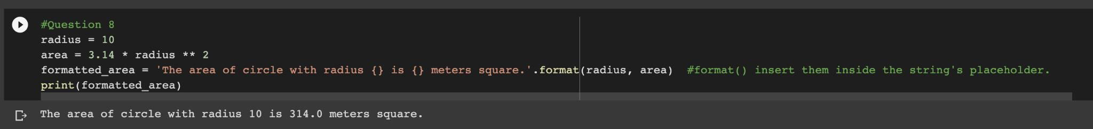

**Explanation:**

* format() is used to insert them inside the string’s placeholder.

**Question9:**

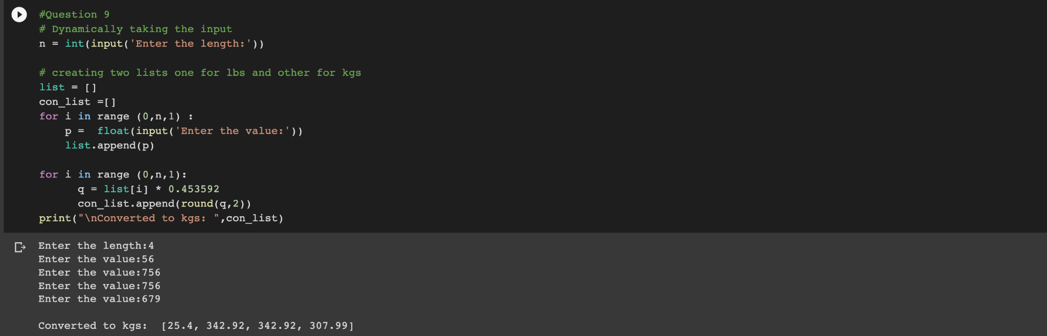

**Explanation:**

* By using input() we can read input from the console.
* I have created a list like list and const_list on for lbs and another for kgs.
* By using a for loop to insert the values in the list from the user.
* By using the loop again for the conversion of lbs to the kgs and appending them to the new

**Question10:**



